GEAR LIST

 | On the bus, include in your backpack:
 | Sunscreen
 | Insect repellent
 | Water bottle
 | Wide brimmed hat +
A small packed morning tea if your school is not having a Daradgee morning tea on the first day
Jen
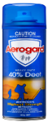
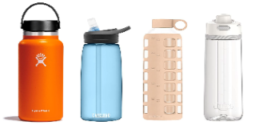
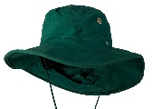

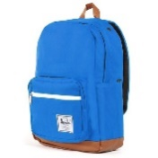
Jen
+
Jen

Jen
Jen
Jen

LABEL EVERYTHING This is generic - please add or omit gear accordingly. Consider how many days you are camping and pack accordingly. Pack older clothes that are ok to get wet and dirty.
Socks
Underwear
Shorts: sun smart and suitable for climbing (knee length)
Shirts: sun smart and suitable for climbing (able to be tucked in)
Track suit / Pyjamas / Evening clothes
Swimwear & rash guard- if going to Babinda Boulders or doing wet challenges
Towels
Wet footwear that will not slip off - crocs, reef sandals or reef booties
Thongs or crocs to wear in the shower
Shoes or joggers (enclosed shoes suitable for climbing). Pack an extra old pair if you have them.
Thongs- for wearing in the shower and at certain other times when approved by teachers.
Raincoat and OPTIONAL gum boots if you have them. It rains a lot here!
Pillow & sheets (one sheet to cover vinyl mattress - mattress provided)
Blanket or sleeping bag
TOILETRIES (kept in a toiletry bag or shopping bag)
Toothbrush and paste
Soap and soap box
Comb/ brush
Deodorant - non aerosol please
Bag for dirty or wet clothes
DO NOT BRING - MOBILE PHONES, CAMERAS, ELECTRONIC DEVICES, LOLLIES, GUM & PERFUMES.

