DARADGEE ENVIRONMENTAL EDUCATION CENTRE

Queensland
Government

Education Queensland
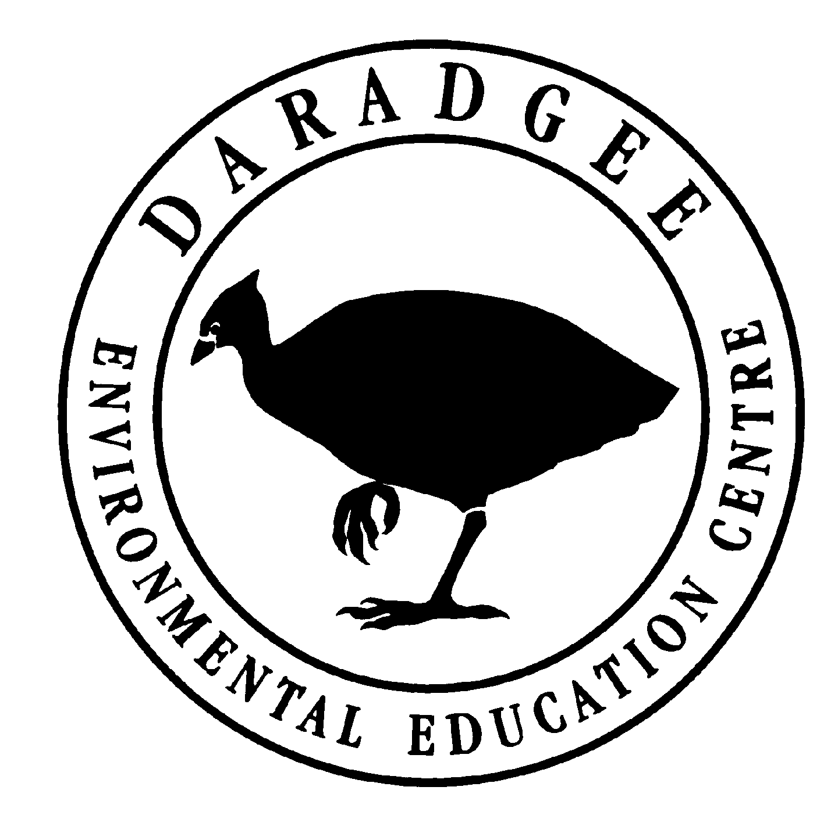
P.O. Box 1810 Innisfail • McAvoy Street Daradgee
Telephone 40631 333

2024
January to June 2024 Bus Prices

Single trips and return: | Small Bus (up to 24) | Large Bus (up to 61)
DEEC to Polly Creek and return | $330 | $350
- to Coconuts and return | $330 | $350
- to Etty Bay and return | $460 | $480
- to Babinda Boulders and return | $460 | $500
- to Paronella Park and return | $460 | $480
- to Henrietta Creek and return | $570 | $590
- to Mamu Canopy Walk and return | $570 | $590
- to Innisfail CBD | $290 | $300
- to Deral (Frankland Island Cruises pontoon) and ret. | $600 | $630
Combination trips: | Small Bus (up to 24) | Large Bus (up to 61)
DEEC to Polly Creek (am), Polly Creek to Coconuts (midday) | $370 | $390
DEEC to Polly Creek (am), Polly Creek to Coconuts (midday), Coconuts to Daradgee (pm) | $490 | $510
DEEC to Polly Creek (am – half group), then to Coconuts (other half).  Polly Creek to Coconuts - swap groups and return to Polly Creek (midday).  Coconuts (half group) to Polly Creek (+ other half) and full group return to DEEC (pm). | $580 | $600
DEEC to Polly Creek (am), Pick up Polly Creek and deliver to Coconuts. Swap groups at Coconuts and deliver to Polly Creek (midday), Pick up Polly Creek and return to DEEC (pm)  Please note: half group will access the DEEC boat for transport from DEEC to Coconuts and return. | $500 | $520

